**Success of the five stakeholder events across Europe**

**More than 150 people attended the five ArtReefs Blue Innovations Labs**

**about recreational artificial reefs for Blue Growth in the Mediterranean and Black Sea.**

Organized in Bulgaria, France, Italy and Spain during November and December 2017, the events were highly participative and served to explain the results of the ArtReefs EU project.

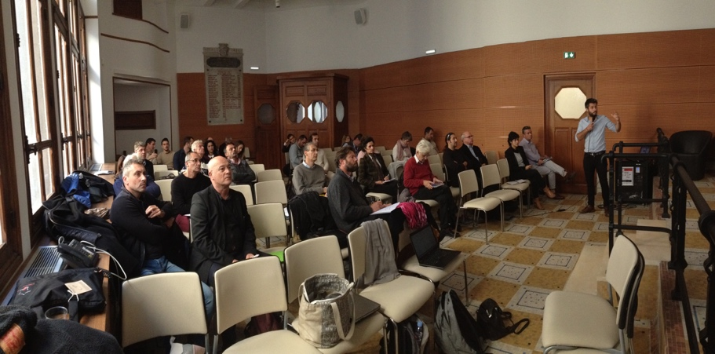

Around 150 participants represented companies, maritime authorities, public administrations, reef managers, universities, tourism operators, neighbour associations, NGOs, fisheries and aquaculture, divers, marinas and recreational fishing clubs. This demonstrated growing interest, as illustrated by a growing number of real projects aiming to serve the environment, as well as communities and business thanks to multi-user models.

Debate was most lively about gaps and challenges related to regulation, licensing and management. Also, the lack of basic economic and environmental data at local level to clarify if such structures can sustain sufficient incomes and services, something instrumental for social support and to mobilise investment. The exchanges also allowed to identify some necessary actions:

* comparable surveys to analyse the economic impact of existing recreational reefs;
* effective and viable compensatory measures to finance the management of artificial reefs;
* more clarity and convergence of the different regulations at national level to help SMEs and administrations understand requirements along the process, and to improve coherence at international level;
* raise awareness about sustainable coastal planning and potential opportunities related to artificial reefs, promoting best practice;
* better quantifying environmental and economic services and interactions to help integrate artificial reefs in regional planning of sustainable development and branding strategies.

**SAVE THE DATE – 12th June 2018**

**A final match-making and brokerage event specific for artificial reef stakeholders in the Mediterranean and Black sea will be held in Pescara, Italy.**

This event will be a unique opportunity to network and promote new projects and partnerships between destinations and stakeholders at international level.

Please check **www.artreefs.eu** for practical deliverables produced till now, and don’t hesitate to contact **info@artreefs.eu** about any issues related to multi-purpose artificial reefs.

If you are interested in developing **tourist packages** including artificial reefs, [a new guide is now available](http://www.artreefs.eu/wp-content/uploads/2017/12/D.2.1_ArtReefs_Guide_Tourism.pdf).

If you’d like to join or stay informed about the **Public-Private Partnership** to promote sustainable Artificial Reefs in the Mediterranean and Black Sea, please [Endorse the initiative](http://www.artreefs.eu/endorse-artreefs-initiative/).

Please check **www.artreefs.eu** for more information on issues related to multi-purpose artificial reefs.

**Project manager**: Mr. Luis LOZANO [llg@innogatetoeurope.eu](mailto:llg@innogatetoeurope.eu)

**About the ArtReefs EU Project**

ArtReefs is 24 months collaborative project co-financed by the European Union through the European Maritime and Fisheries Fund managed by the Executive Agency for SMEs.

Its aims to promote the use of custom-designed artificial reefs as versatile infrastructures to sustain innovative economic activities while providing beneficial services for nature, leading to the creation of jobs and greater cooperation between related stakeholders. It also aims to increase awareness on marine environmental challenges and deliver practical tools for sustainable coastal planning.

The project brings together the expertise of six organisations:

* **Innogate to Europe**: a Spanish SME specialised in innovation and entrepreneurship;
* **CNR-ISMAR**: the marine branch of the Italian National Research Council;
* **Pôle Mer Méditerranée** from France, the largest maritime cluster in the region;
* **National Tourism Cluster “Bulgarian Guide”**, specialised in sustainable and alternative tourism;
* **The Italian region of Abruzzo**, leading Integrated Coastal Management in the Adriatic;
* **The Union of Bulgarian Black Sea Local Authorities**, a regional network of 21 municipalities in the Black Sea.

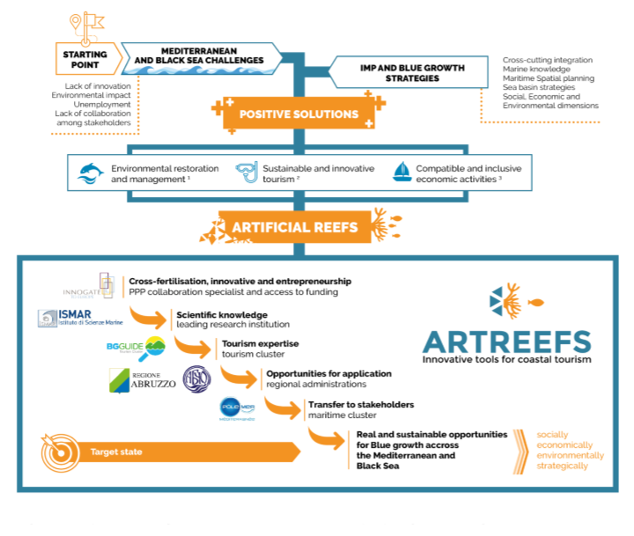

**More information:** [www.artreefs.eu](http://www.artreefs.eu)

**Project manager**: Mr. Luis LOZANO [llg@innogatetoeurope.eu](mailto:llg@innogatetoeurope.eu)

**Communication**: Mr. Colin RUEL [ruel@polemermediterranee.com](mailto:ruel@polemermediterranee.com)